Materials and tools used for making a bottle fan

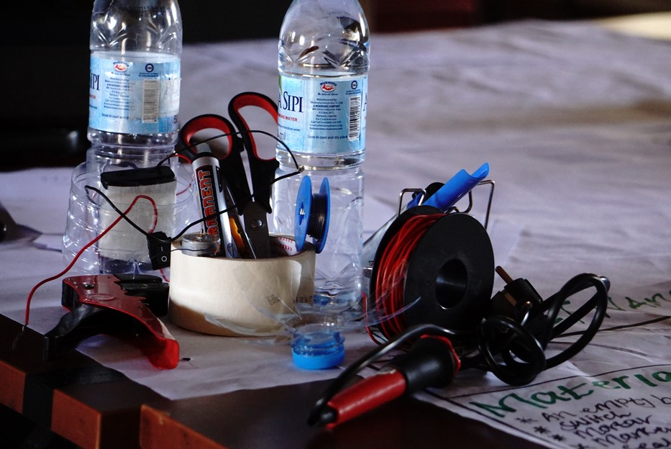

Before we started, the team list the materials and tools needed to complete the project, and where collected in one place.

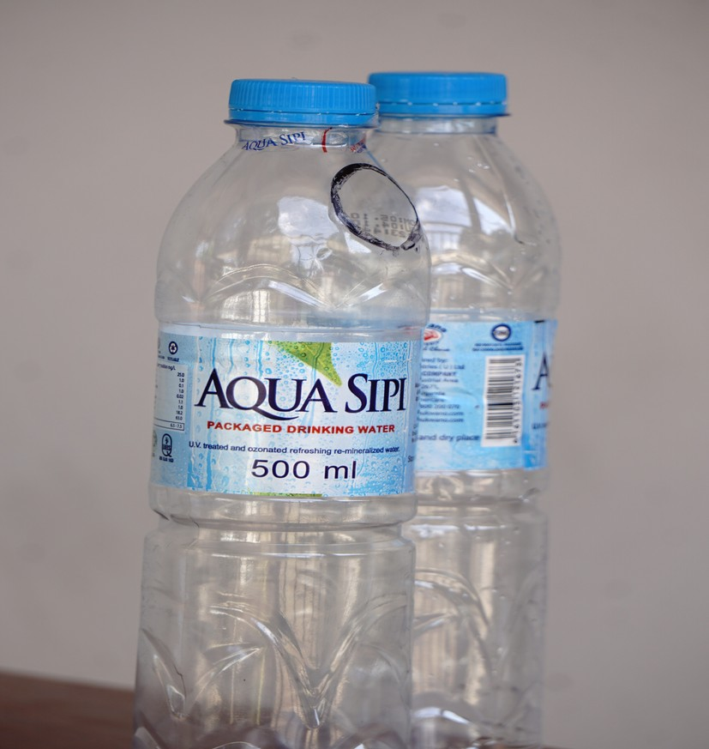
Empty Bottles of water

Two empty bottles
One for erecting the fan and other for making the propeller and switch holder

Seal Tape and Marker Pen

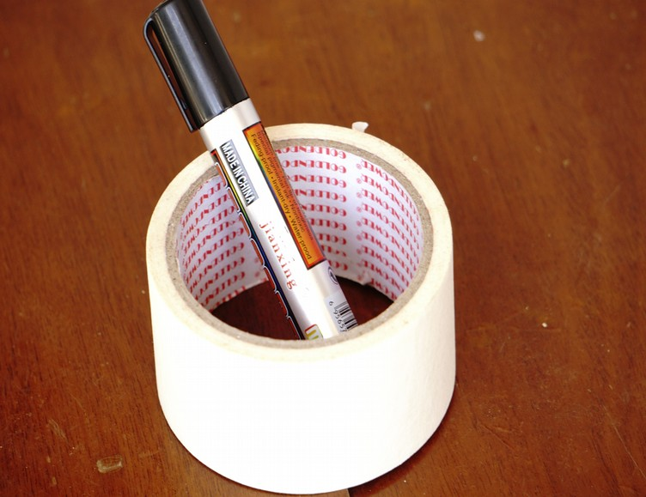

Seal tape was used for sealing anything on the bottle and empty or open wire
Marker pen was used for drawing.

Wire
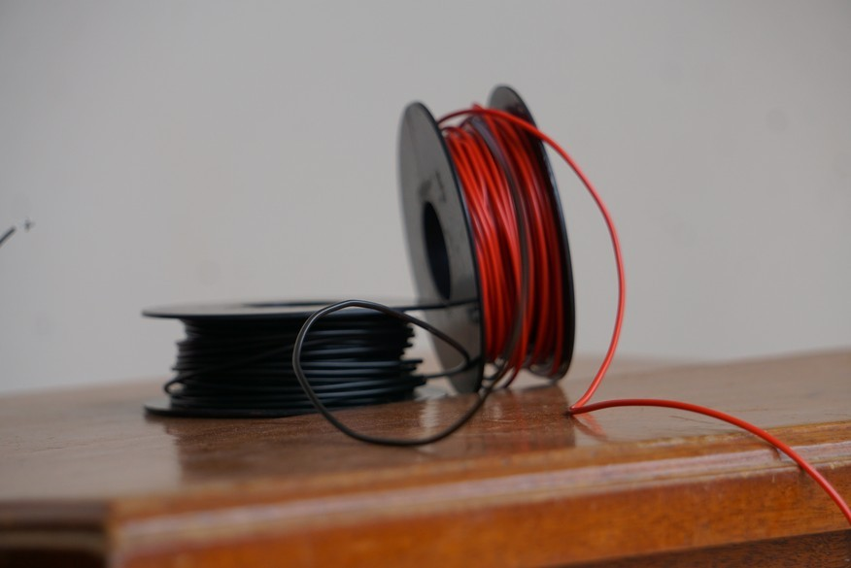

For continuity or Connections

Supper-glue
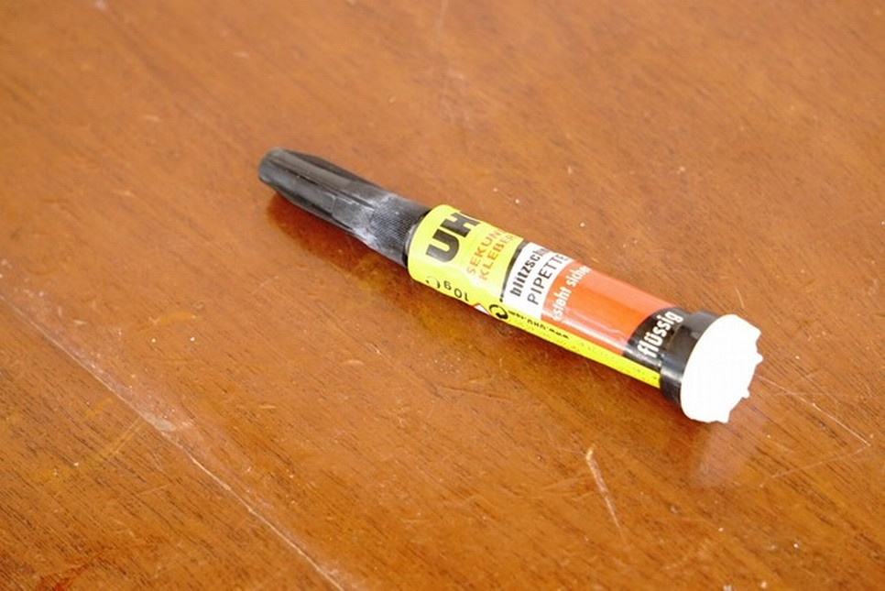

Gluing anything on the bottle
Battery
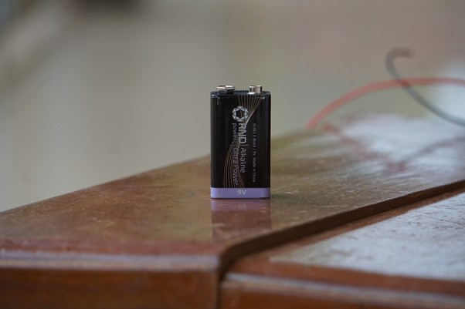

To provide power energy for the fan

Scrapping Wire
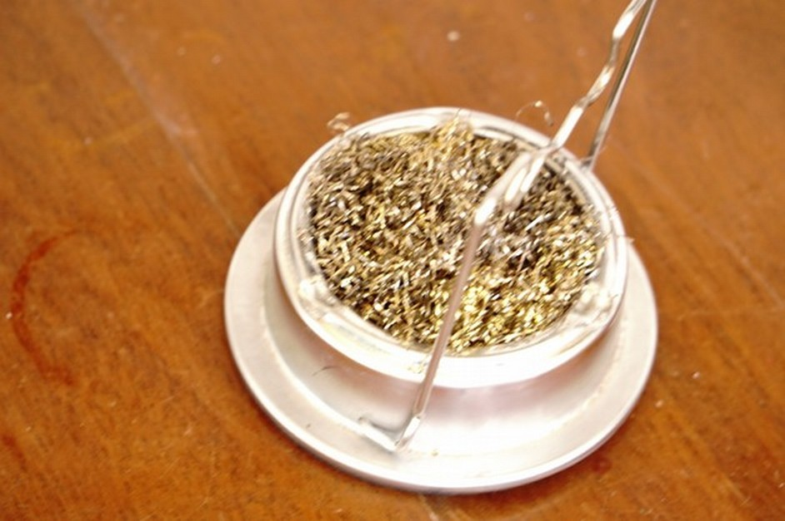

For scrapping the soldering gun

Soldering Wire
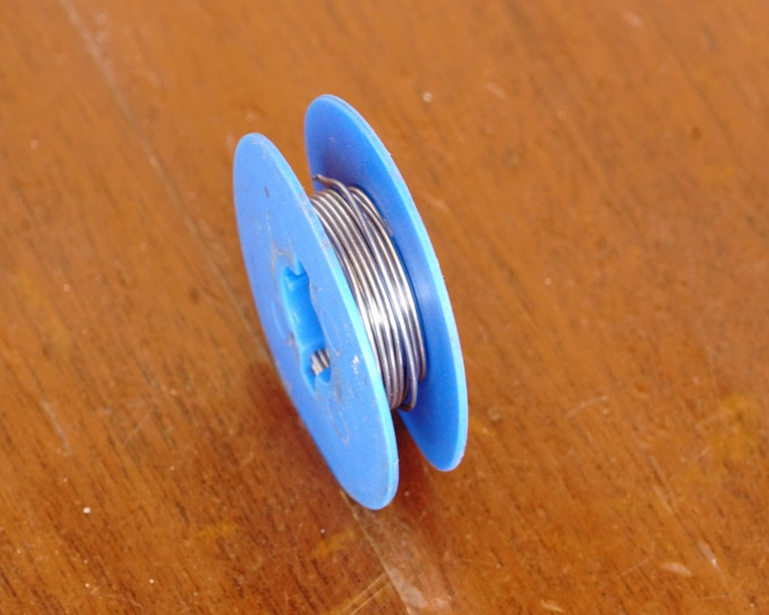

Help in connection, for sealing wire on the switch
Cutter
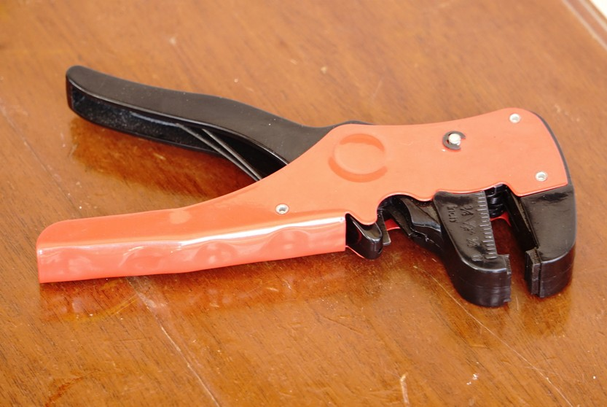

For cutting wires and bottle

Scissor
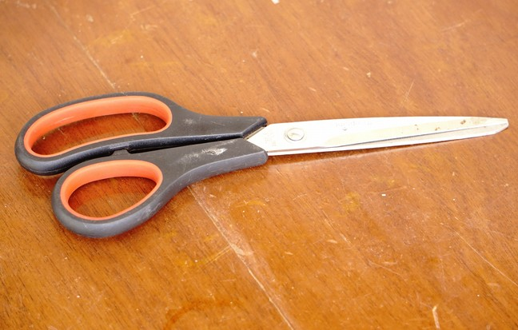

For cutting bottle and some wires

Soldering Gun
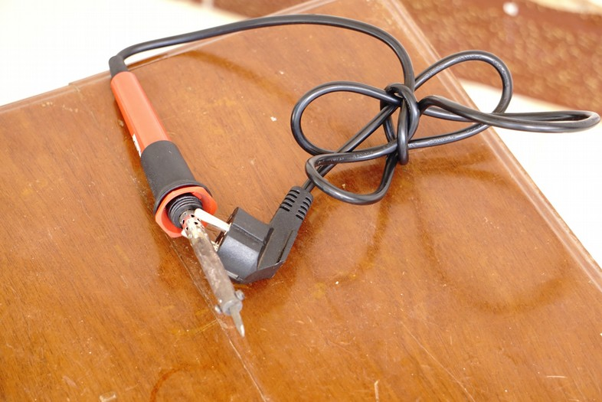

For soldering the wire on the switch

Switch
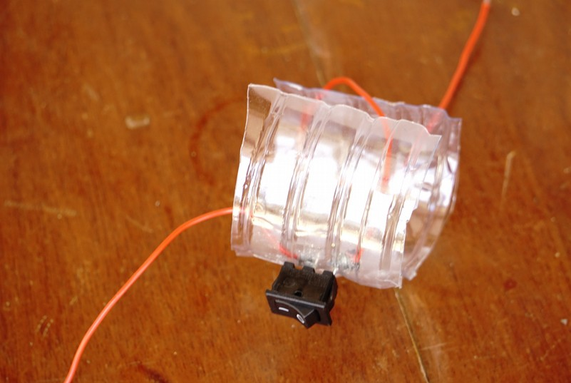

For switching on and off the fan

